|  |  |  |  |  |
| --- | --- | --- | --- | --- |
| Year 12 Physics – Topic Test  **Relativity and the Standard Model** | | | | |
|  | | | | |
| Name**: ANSWER KEY** | | | Teacher: | |
| **Time allowed**: 60 minutes. | | | | |
| **Section** | Number of questions | Your Mark | Marks available | Percentage of Test |
| **Section One:**  Short answer | 7 |  | 27 | 45 |
| **Section Two**:  Extended answer | 3 |  | 33 | 55 |
|  | **Total** |  | **60** | **100** |

**Section One:** Short answer

**Question 1**  **[3 marks]**

1. Within the Standard Model, what is each generation composed of?

**Two leptons and two quarks.**

1. Suggest one reason why the Standard Model is considered incomplete

**e.g. does not include gravity, does not describe dark matter**

1. If a pion (π+) is made from an up quark and a down antiquark what is an antipion (π-) made from?

**An up antiquark and down quark.**

**Question 2**   **[4 marks]**

Fill in the missing particle in each of the following equations. A table of baryon and lepton numbers is included (note that although antiparticles have not been listed, they are possible particles in the below reactions)

|  |  |  |  |  |  |  |
| --- | --- | --- | --- | --- | --- | --- |
| **NAME** | **SYMBOL** | **Charge (Q)** | **Baryon Number (B)** | **Electronic Number (Le)** | **Muonic Number (Lμ)** | **Tauonic Number (Lτ)** |
| Proton | p | +1 | +1 | 0 | 0 | 0 |
| Neutron | n | 0 | +1 | 0 | 0 | 0 |
| Electron | e- | -1 | 0 | +1 | 0 | 0 |
| Muon | μ- | -1 | 0 | 0 | +1 | 0 |
| Tau | τ- | -1 | 0 | 0 | 0 | +1 |
| Electron neutrino | νe | 0 | 0 | +1 | 0 | 0 |
| Muon neutrino | νμ | 0 | 0 | 0 | +1 | 0 |
| *Tau neutrino* | ντ | 0 | 0 | 0 | 0 | +1 |

Conservation rules mean that charge, baryon numbers and lepton numbers must be conserved. Which of the following particle interactions are possible? Give a reason for your choices.

$$\overline{p}$$

$${\overline{ν}}_{e}$$

$$e^{+}$$

$$μ^{+}$$

1. $p+p→p+p+p+______$**(1)**
2. $n→p+e^{-}+ ______$**(1)**
3. $p→n+ν_{e}+ ______$**(1)**
4. ${\overline{ν}}_{μ}+p→n+______$**(1)**

**Question 3**  **[4 marks]**

Describe two experimental observations that support the Big Bang model of the universe.

Cosmic microwave background radiation (1)

The Universe had a high temperature at the beginning. During its expansion, it cooled and radiation fell to its present value (1)

Red shift observed in spectral lines (1)

Doppler shift indicates that distant galaxies are moving apart (1).

The predicted abundance of the simplest chemical elements (1)

Hydrogen & Helium are common elements in our universe formed during the later stage of the Big Bang. (1)

**Question 4 [4 marks]**

An astronaut flies past an observer at a constant 85% of the speed of light in the reference frame of the observer. His spacecraft has light A at the front and light B at the rear. When the astronaut is directly in front of the observer as shown, he sees the two lights A and B illuminate simultaneously.

0.85 c

Light B

Light A

Observer

Astronaut

1. From the frame of reference of the astronaut explain what order the lights will go on for the observer.

The astronaut predicts that the observer will see B then A. ✓

According to Einstein’s special relativity the speed of light is constant in any reference frame. The observer is moving to the left in the astronaut’s frame of reference so the light from A has to travel further to reach the observer so the observer will see this flash second. ✓

**(2)**

1. The astronaut and the observer both have identical stopwatches set to countdown from one minute. As the astronaut passes the observer both stopwatches commence their countdown. The astronaut states that his own stopwatch will finish the countdown first but the observer states the opposite. Explain who is correct and why.

The observer sees the astronaut moving close to speed of light and concludes that the time between the astronaut’s ticks takes longer on the moving clock – so effectively the rate of time passing slows down.

In the frame of reference of the astronaut the observer is moving so the observer’s clock will take longer than the astronaut’s countdown. ✓

Both are correct in their own frame of reference ✓

**(2)**

**Question 5**  **[3 marks]**

A probe is being sent to a planet outside our solar system. From Earth the planet is measured to be 40 light years away. At what velocity does the probe need to travel to give a distance of 20 light years? Your answer can be expressed in terms of the speed of light (*c*).

|  |  |
| --- | --- |
| Description | Marks |
|  | **1** |
|  | **2** |

**(3)**

**Question 6 [5 marks]**

Two spaceships are travelling past Earth side by side, both at 0.75c. The captain of the first spaceship sends a radio signal to the captain of the second spaceship. The captain of the second ship then sends a return signal. This situation is illustrated below.

The captains of the spaceships record the time for the signals to pass between them as less than what an observer at the space command centre on Earth records. With the aid of a labelled diagram and a supporting description, explain this apparent contradiction. You may use the original diagram as a base to start with.

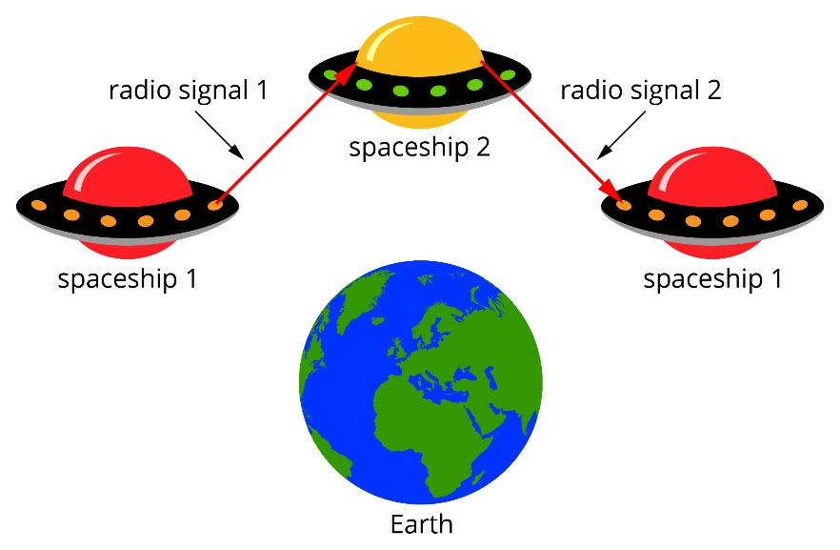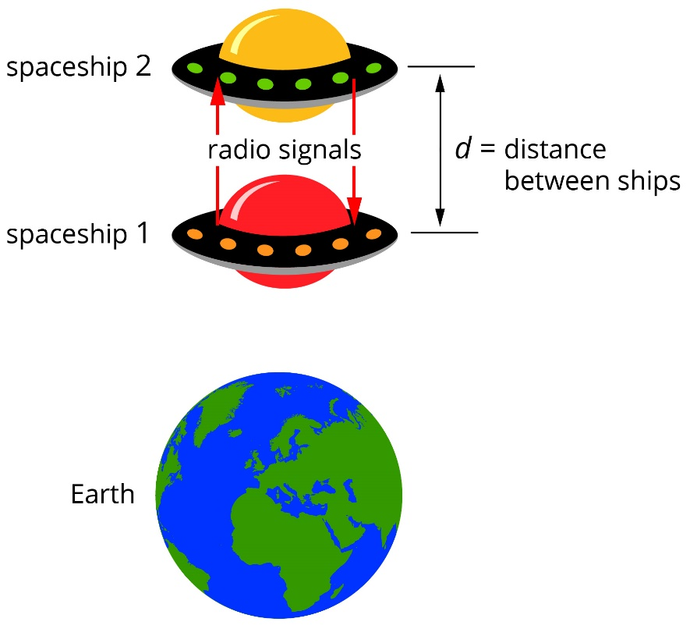

Motion

|  |  |
| --- | --- |
| Description | Marks |
| Suitable diagram (such as that above) showing distance travelled by light is greater for Earth observer | 2 |
| The signal from the perspective of the ships’ captains travels 2d, so time for signal to be sent and return is given by: | 1 |
| From the Earth observer’s frame of reference, because the ships are moving, by the time the signal from ship 1 reaches ship 2 the distance for the light to travel from ship 1 to ship 2 is greater than d. Similarly for the return signal. | 1 |
| If we let x be the distance from the Earth observer’s perspective, then time from the Earth observer will be:    . | 1 |

**(5)**

**Question 5 [4 marks]**

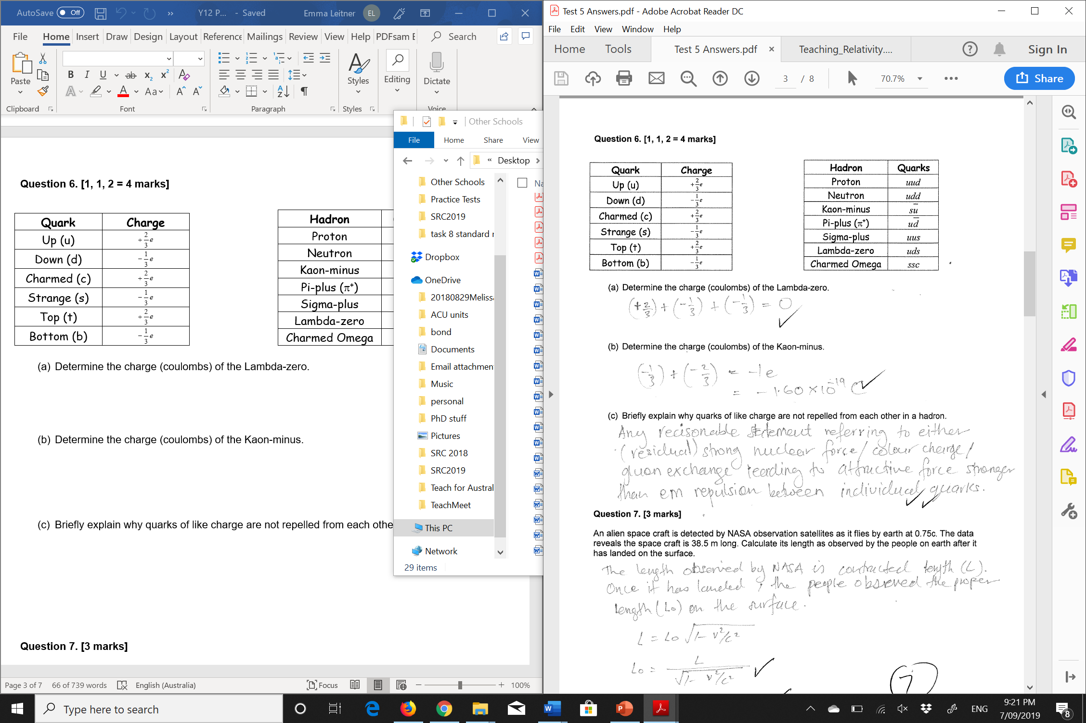

**Section Two:** Extended answer

**Question 8 (11 marks)**

Observations of the luminosity of a supernova in a distant galaxy indicate that it is 50 mega parsecs away from Earth. Analysis of the helium spectrum from the supernova shows that the yellow line that usually occurs at a wavelength of 587.6 nm (λ0) was measured for this galaxy to be at 595.3 nm (λ1)

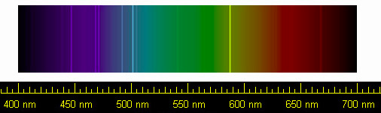

1. What does the change in wavelength of the yellow line in the helium spectrum for this distant galaxy indicate about its motion?

|  |  |
| --- | --- |
| Description | Marks |
| The wavelength of the yellow line has increased, indicating a Doppler shift due to the distant galaxy moving away from the Earth. | 1 |

1. Calculate the velocity of the galaxy from this spectral data, given **v = (Δλ/λ0) c**

|  |  |
| --- | --- |
| Description | Marks |
| Δλ = 595.3 nm - 587.6 nm = 7.7 nm | 1 |
| v = (Δλ/λ) c = (7.7 nm/587.6 nm) (3 x 108 m/s) = 3.93 x 106 m/s | 1 |

1. Use the data from this galaxy to estimate a value for Hubble’s constant Ho. where **v = Ho d**.

|  |  |
| --- | --- |
| Description | Marks |
| v = Ho d ➔ Ho = v/d = (3.93 x 106 m/s)/50 Mpc | 1 |
| = (3930 km/s)/50 Mpc = 78.6 km/s/Mpc  - ½ for leaving in ms-1 | 1 |

aa

1. A phenomenon common to most forms of waves was used to explain the changes in observable wavelength produced by the stars. What is this name given to this phenomenon? Briefly explain how it occurs using a context other than light. A diagram may be useful.

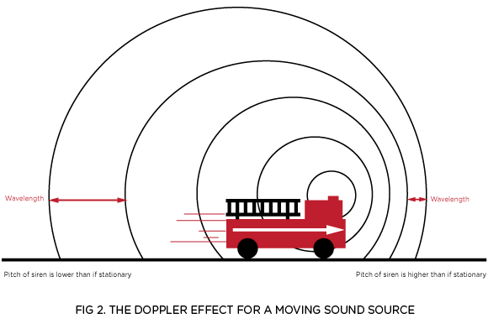

|  |  |
| --- | --- |
| Description | Marks |
| Diagram | 1 |
| Doppler Effect | 1 |
| Explanation – based on wavelength change | 1-2 |

**(4)**

1. The currently accepted explanation for red shift is a little more complicated. It is now suggested that the change in wavelength is due to the expansion of the universe and not really the motion of the stars themselves. We believe that the stars are not actually moving, in as much as it is the space between them that is expanding instead. Explain how the expansion of the universe might account for this apparent red shift.

|  |  |
| --- | --- |
| Description | Marks |
| As space expands, the light waves themselves expand. | 1 |
| This causes causing the light’s wavelength to increase (shifting it to the red end of the spectrum). | 1 |

**(2)**

**Question 9 (11 marks)**

An electron at rest is being accelerated in the Australian Synchrotron to a velocity that is 0.9997 that of the speed of light.

1. What would be the mass-energy equivalence of the electron at this speed? (2 marks)

E = mc2 / √(1-v2/c2)

E = 9.11 x 10-31 x (3 x 108)2/ √(1-0.99972) (1)

E = 3.35 x 10-12 J (1)

1. How much kinetic energy was gained by the electron to travel at this speed? (3 marks)

Ek = mc2 / √(1-v2/c2) – m c2 (1)

Ek = 3.35 x 10-12 - 9.11 x 10-31 x (3 x 108)2 (1)

Ek = 3.26 x 10-12 J (1)

1. Calculate the relativistic momentum of the electron. (2 marks)



pv = 9.11 x 10-31 x 0.9997 x 3 x 108 / √(1-0.99972) (1)

pv = 1.12 x 10-20 kgms-1 (1)

1. Using the relative mass of the electron, calculate the magnetic field required to keep the electron in orbit if the radius of the Australian Synchrotron is 35.0 m. (4 marks)

m = pv / v

m = 1.12 x 10-20/ (0.9997 x 3 x 108) (1)

m = 3.719 x 10 -29 kg (1)

b = mv/rq = 3.719 x 10 -29 x 0.9997c / (35 x 1.6 x 10-19) (1)

b = 1.99 mT (1)

**Question 10 (11 marks)**

A long time ago, in a galaxy far far away … there was a rather heated space battle…. During the battle, the following observations were made.

1. The captain of spaceship *A* observes enemy spaceship *E* escaping with a relative velocity of 0.48*c*, as shown in the diagram below. A missile *M* is fired from ship *A*, with a velocity of 0.72*c* relative to ship *A*. What is the relative velocity of approach of missile *M*, observed by the crew on ship *E*?

$$v$$

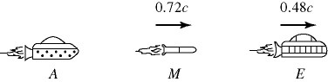

$$u= ?$$

$$u^{'}$$

|  |  |
| --- | --- |
| Description | Marks |
| $$u=\frac{v+ u^{'}}{1+\frac{v u^{'}}{c^{2}}}$$ | 1 |
| $$u=\frac{-0.48c+ 0.72c}{1+\frac{-0.48c x 0.72c }{c^{2}}}$$ | 1 |
| $$u=\frac{0.24c}{0.6544} =0.367c$$ | 2 |
| $$1 mk for formula only if values incorrectly assigned.$$ $$3 mks if only error is using+ve value for v answer then→0.892c$$ |  |

1. Three spaceships *A*, *B*, and *C* are in motion, as shown in the figure. The commander on ship *B* observes ship *C* approaching with a relative velocity of 0.78*c*. The commander also observes ship *A*, advancing in the rear, with a relative velocity of 0.31*c*. What is the velocity of ship *C*, relative to an observer on ship *A*?

$$u$$

$$v$$

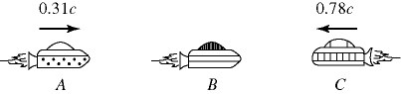

$$u^{'}$$

|  |  |
| --- | --- |
| Description | Marks |
| $$u^{'}=\frac{u-v}{1-\frac{v u}{c^{2}}}$$ | 1 |
| $$u^{'}=\frac{0.78c--0.31c}{1-\frac{-0.31cx0.78c}{c^{2}}}$$ | 1 |
| $$u^{'}=\frac{1.09c}{1.2418}=0.878c$$ | 1 |

After the battle the victorious ship (travelling at relativistic speeds) passes a friendly space station. The science officer aboard the victorious ship decides to conduct a simple experiment (**diagram A**), by shining a beam of light onto a mirror that is a distance **d** away, and timing how long the reflection takes to return to her. Her value for the time taken by the light to travel to the mirror and back is

**t0 = 2d/c**

**l**

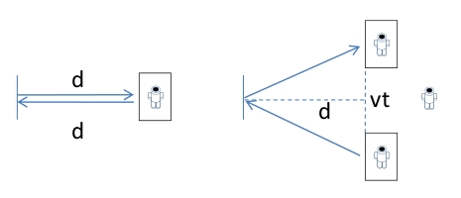

A

B

**l**

While she conducts this simple experiment, a second astronaut observes the experiment from the space station as the relativistic spacecraft speeds past at velocity **v**.

He sees the beam of light follow the path shown in **diagram B** due to the motion of the spacecraft.

1. Show mathematically that the time he measures for the light travelling to the mirror and back is given by the expression below. Clear logic should be set out.

$$t = \frac{2 \sqrt{d^{2}+\frac{1}{4}v^{2}t^{2}}}{c}$$

|  |  |
| --- | --- |
| Description | Marks |
| The light travels a distance 2l in his reference frame at the same constant speed c, so the time the light takes is given by  t = 2l/cwhere l is the hypotenuse of a right-angled triangle with other sides d and ½ vt | 1 |
| by Pythagoras $$l^{2} =d^{2}+{\left(\frac{1}{2vt}\right)}^{2}$$ | 1 |
| $$l = \sqrt{d^{2}+\frac{1}{4} v^{2}{ t}^{2}}$$ | 1 |
| $$v=\frac{s}{t} t=\frac{s}{v} t=\frac{2 l}{c}$$ $$t =\frac{2 \sqrt{d^{2}+\frac{1}{4} v^{2}{ t}^{2}}}{c}$$ | 1 |

**(4)**